Mt.  Carmel  Baptist  Church  The vision of our church is to take the gospel to people and bring them to membership in God’s family, disciple them to Christlikeness, help them identify their spiritual gifts, and equip them for their ministry in the church and Christ’s mission in the world. |  |  | Ministry Staff:  Josh Taylor, Senior Pastor  706-754-9566 joshoutloud.com@gmail.com  Cindy Pruitt, Secretary  706-754-1407 mcbcdemorest@yahoo.com  Ricky Ward, Music Director  Wendy O’Connor, Sunday School Director  Weekly Schedule  Sunday  Sunday School: 10:00 am – 10:45 am  Morning Worship Service: 11:00 am  Choir Practice: 5:00 pm  Evening Worship: 6:00 pm  Children’s/Youth Activities: 6:00 pm  Wednesday  Adult Bible Study: 7:00 pm  Youth Service: 7:00 pm  Children's Classes: 7:00 pm  Contact Us  Mt. Carmel Baptist Church  988 441 Historic Hwy N  Demorest, GA 30535  706-754-7505  www.mtcarmeldemorest.com  facebook.com/mtcarmeldemorest | 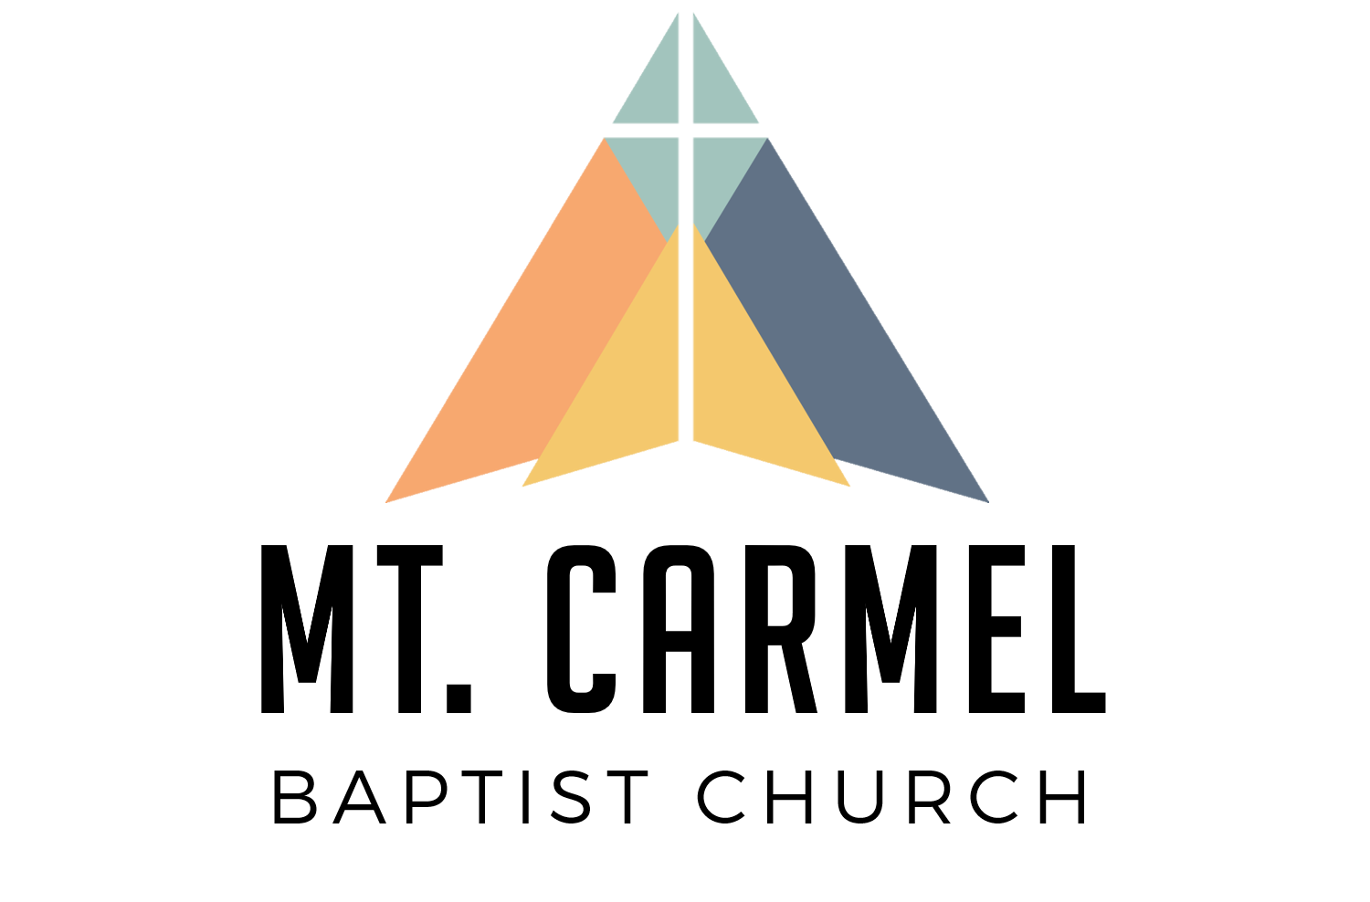 | Campus  Map

Sunday School Directory  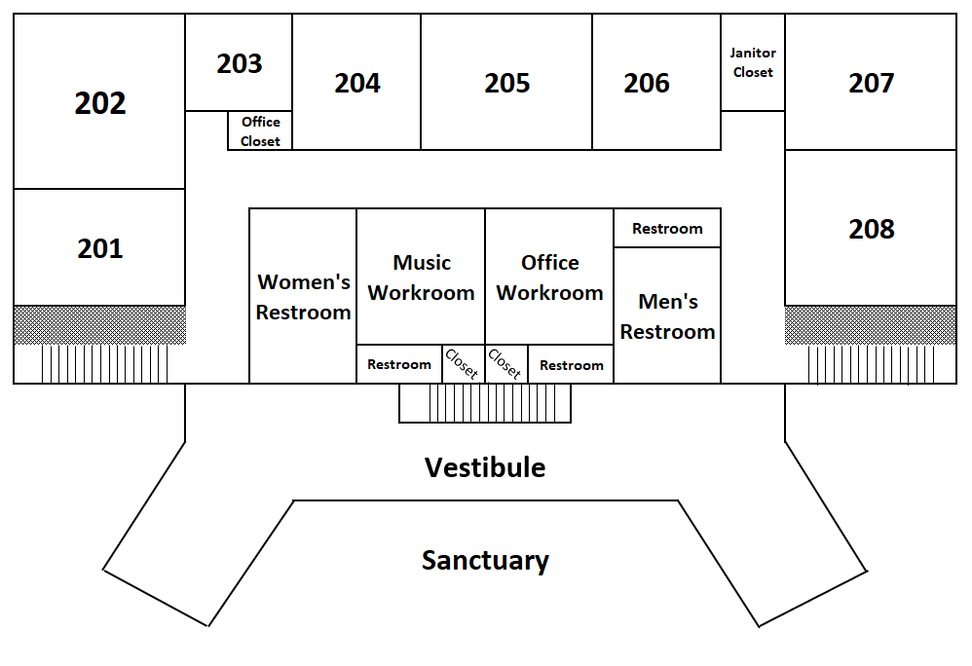  Children & Youth  Baby Room 102  Toddler Room (Ages 1-2) 104  Preschool (Ages 3-4) 103  Kindergarten (Age 5) 301  1st–2nd Grade 307  3rd-5th Grade 306  6th-12th Grade 302  6th-12th Grade (Overflow) 308  College & Career 304  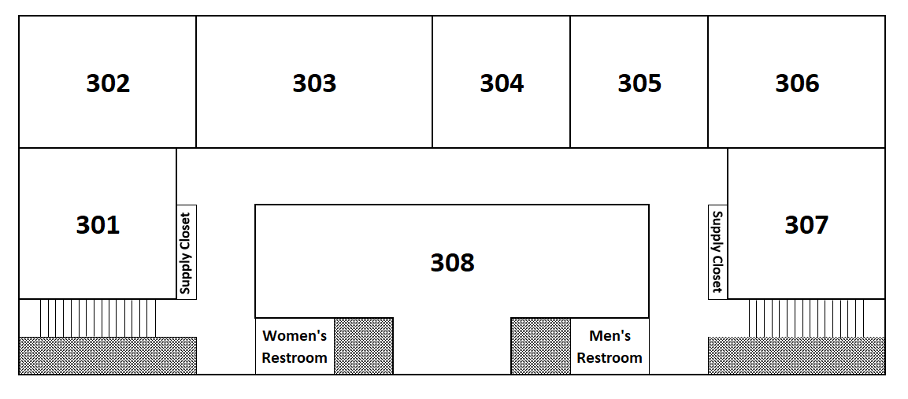  Anyone  Young Adults 303  (36 & Under Overflow) 305  Adult Combo Sanctuary  Misfits Fellowship Hall  Bible Explorers 207  Women  JOY 202  Men  Men’s 208 | Main Level  Upper Level |  | 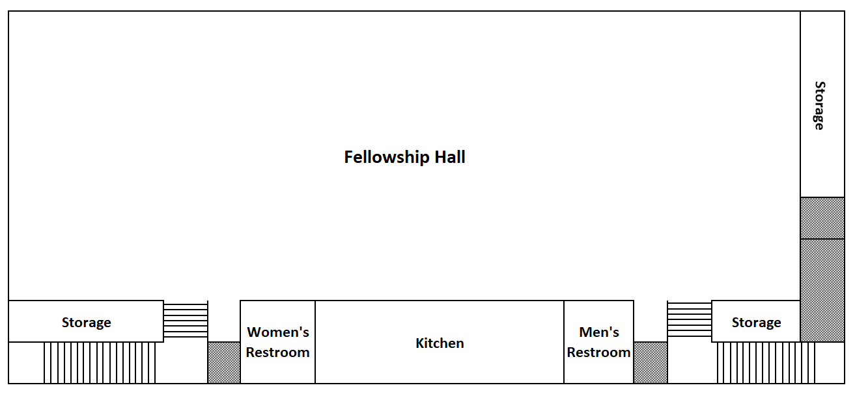  Fellowship Hall  Lower Level  