Discover this event in the YouVersion Bible App.

1. You will ____ your ____ as ____ sees your ____. (5)
2. You will ____ ________ what you _________. (6-10)
   * ______ _______ and _______ ________.
3. You will be _______ no ____________. (11)

***So What?***

**________ _______ before you are ________ _______!**

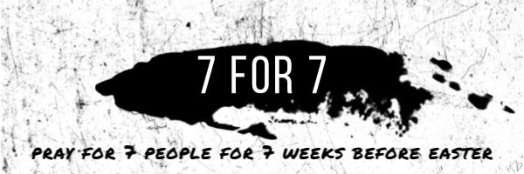

1. ___________________________________________
2. ___________________________________________
3. ___________________________________________
4. ___________________________________________
5. ___________________________________________
6. ___________________________________________
7. ___________________________________________

