Discover this event in the YouVersion Bible App.

1. He ___________ His ____________. (12-13, 19a)
2. He ___________ His ____________. (19b-21)
3. He ___________ His ____________. (22-23)

***So What?***

**It’s** ___________ **for one** ___________ **man to die for all** ___________ **people!**

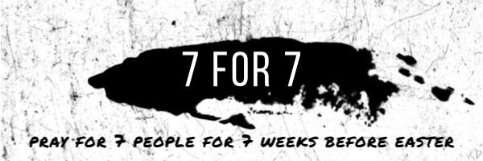

1. ___________________________________________
2. ___________________________________________
3. ___________________________________________
4. ___________________________________________
5. ___________________________________________
6. ___________________________________________
7. ___________________________________________

