**Salvation Triangle: Side 1**

*Romans 3:24-26*

**Passage Background and Context Information**

* In the first section of Romans, God promises to judge each person fairly and give him or her either the punishment or reward he or she deserves, and we all deserve God’s wrath because of our sins. No one can withstand God’s judgment. Everyone is guilty. God’s justice would be compromised if He failed to punish our sins. God would become as unrighteous as us if He overlooked our sins and did not condemn us. How can this be with such a loving God?! The gospel brings a novel way of administering God’s saving justice.

**The Question**

* How can God be just if He declares us righteous?

**Bible Verse**

###### Romans 3:24-26 (CSB)

24They are justified freely by his grace through the redemption that is in Christ Jesus.

25God presented him as an atoning sacrifice in his blood, received through faith, to demonstrate his righteousness, because in his restraint God passed over the sins previously committed.

26God presented him to demonstrate his righteousness at the present time, so that he would be righteous and declare righteous the one who has faith in Jesus.

1. 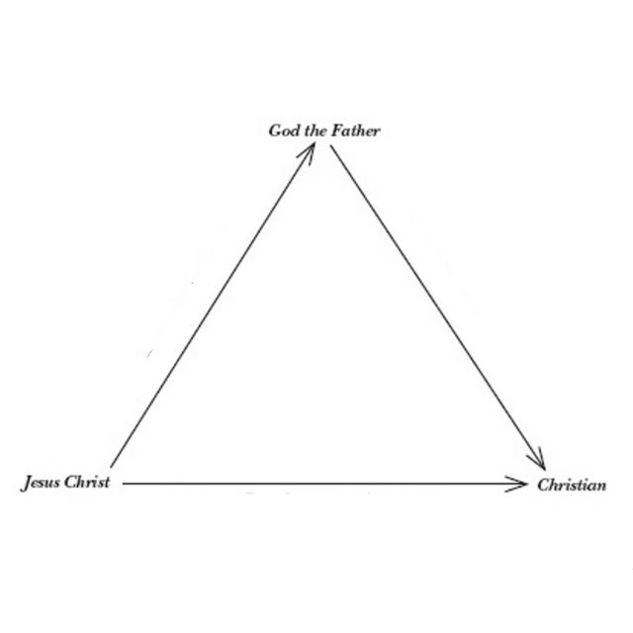**God _________ us by _____ through _____ in ______ ______!**

**Justification: ______________________________________________**

**Justification is a ____ of ____ _____.**

* John 15:25 “They hated me without reason.”
* D. Martyn Lloyd-Jones has written, “There is no more wonderful word than ‘grace.’ It means unmerited favor or kindness shown to one who is utterly undeserving.… It is not merely a gift, but a gift to those who deserve the exact opposite, and it is given to us while we are ‘without hope and without God in the world.’
* Romans 1:17 “It is through ***faith*** that a righteous person has life.”

**Pray**

“Jesus, I confess I am a sinner. I deserve Your judgment of death and hell. But I believe You love me, came down for me, lived a perfect life, and shed Your blood and died on the cross for my sins. I also believe that God raised You from the dead to forgive my sins, change me, and grant me everlasting life. Please forgive me, change my heart, and give me eternal life. I believe You are my Forgiver and God. I give my life to love, obey, and make much of You! In Jesus’ name, amen.”

• • •

As you add days to my life, Lord, I beg you to add repentance and correction. As I grow older, may I also increase in grace and favor with you and all your people.

…

You have bought and redeemed me with the blood of your only-begotten Son. You have saved me from the torments of hell and the bondage of Satan.

You have freely justified me by faith in Christ, made me right with God—even though I am by nature a child of wrath.

…

Give me grace, as one of your children of light, to walk in holy obedience before your face this day. Help me to keep faith and a clear conscience toward you, and toward all, in all my thoughts, words, and dealings.

…

—Lewis Bayly, “Morning Prayer and Thanksgiving.” in R. Elmer (Ed.), Piercing Heaven: Prayers of the Puritans (pp. 252–253). Bellingham, WA: Lexham Press.

• • •

If you prayed that prayer, the next step in your walk with the Lord displays that private confession and commitment publicly. And the way Jesus has commanded us to do that is through baptism. In baptism, when you go under the water, you’re saying, “I believe Jesus died for my sins.” And when you come up out of the water, you’re saying, “I believe Jesus rose again, has forgiven me, and I’m going to live a new life with him.” If you’ve never been baptized, I want to encourage you to do one of three things.

Check off “baptism” on the back of the tear-off panel and drop it in the offering box on your way out.

Text BELIEVE to 706-525-5351, our text in church number.

Or visit our website, www.mtcarmeldemorest.com/baptism, and go to the baptism tab and fill out that form. Allow me to speak to you about your next right step. You’re not signing up; we’re just talking.

• • •