Salvation Triangle: Side 2 & 3 — Redemption & Propitiation

Romans 3:24-26

Passage Background and Context Information

Because of evil’s deceitfulness and God’s forbearance, we do not feel the immediate need to repent and trust in Jesus. That is why God, in His grace, love, and compassion, disclosed it to us in His written word. In the first section of Romans, God reveals that we all have sinned against Him and continue to fall behind in His expectation for our lives. Because of this, we deserve His wrath, His righteous anger against our sins for all eternity, in a word, hell. Paul clarifies that no one can withstand God’s judgment. We all deserve to be condemned. But we know that God is also an infinitely loving God. So, can God just grant us amnesty? Can he just look the other way and sweep our sins under the rug? No. God must remain just, or his compromises His own character, including His love. He cannot fail to punish our sins. He must punish us for our sins. The gospel is the good news of God’s gift of administering saving justice. God forgives, acquits, justifies, declares us righteous, and reinstates us as His children and fellow heirs of the kingdom of God. While this gift if free to us, it was costly to God.

The Question: What is the cost of justification?

Romans 3:24-26 (CSB)

24They are justified freely by his grace through the redemption that is in Christ Jesus.

25God presented him as an atoning sacrifice in his blood, received through faith, to demonstrate his righteousness, because in his restraint God passed over the sins previously committed.

26God presented him to demonstrate his righteousness at the present time, so that he would be righteous and declare righteous the one who has faith in Jesus.

1. God _________ us through the __________ in _____ as the ___________ for our _____.

# Salvation Triangle

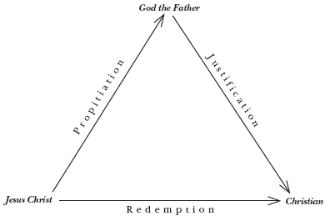

Redemption is ________ by ______.

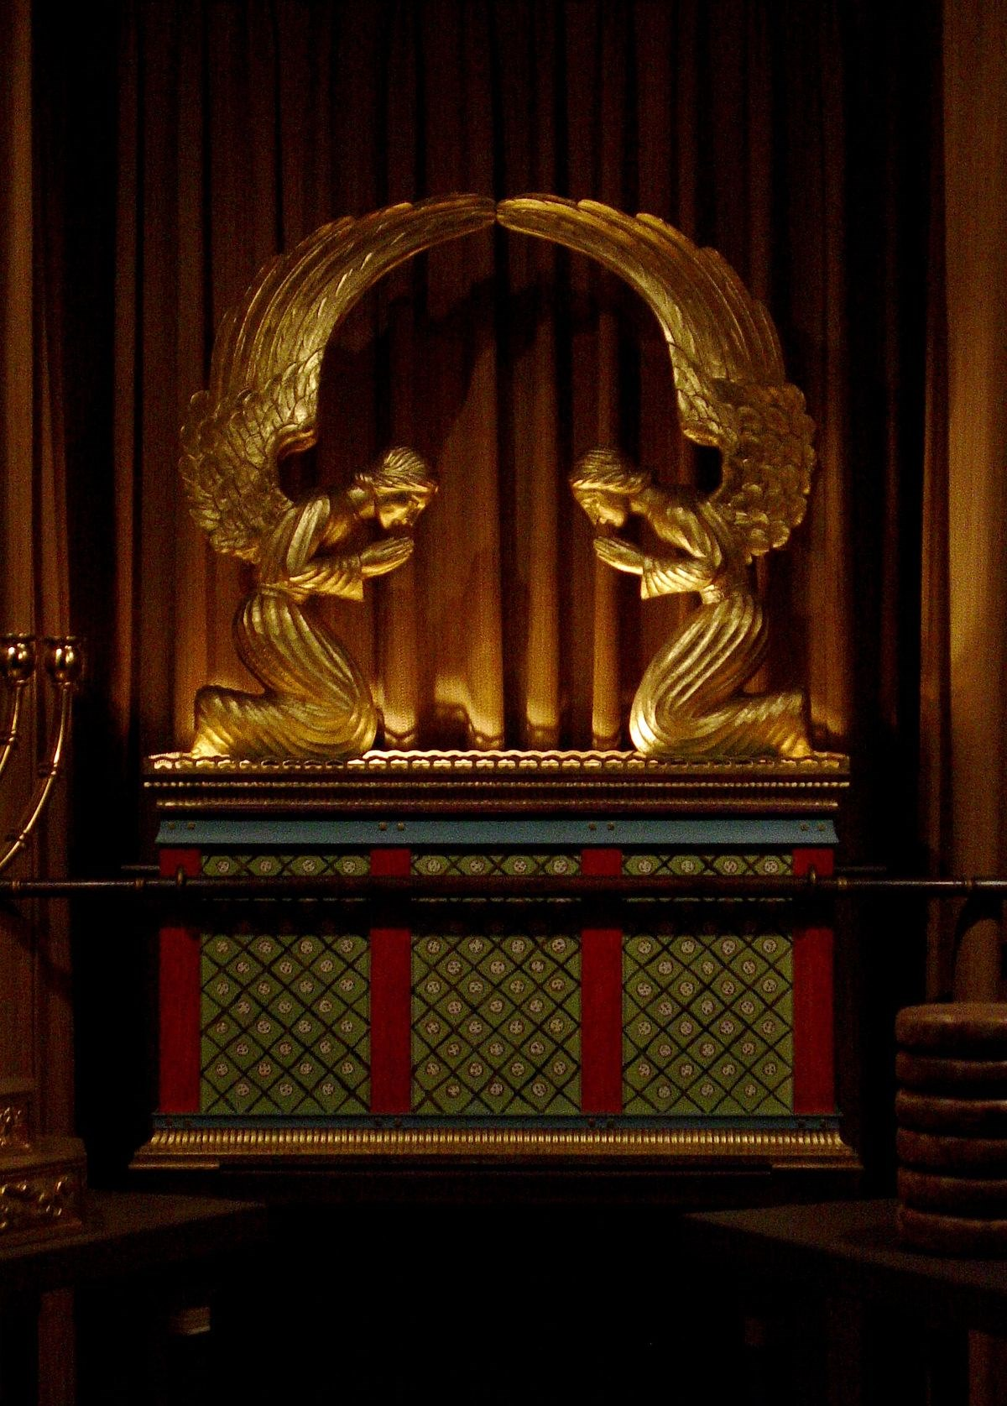

To propitiate is to _____ _________ and _____ _____ the ______ of God.

Leviticus 17:11 “For the life of a creature is in the blood, and I have appointed it to you to make atonement on the altar for your lives, since it is the lifeblood that makes atonement."

• Jesus’ blood is the means of dealing with ___.

* 1 Peter 1:18-19 18 For you know that it was not with perishable things such as silver or gold that you were redeemed from the empty way of life handed down to you from your ancestors,19 but with the precious blood of Christ, a lamb without blemish or defect.

# Pray

“Jesus, I confess I am a sinner. I deserve Your judgment of death and hell. But I believe You love me, came down for me, lived a perfect life, and shed Your blood and died on the cross for my sins. I also believe that God raised You from the dead to forgive my sins, change me, and grant me everlasting life. Please forgive me, change my heart, and give me eternal life. I believe You are my Forgiver and God. I give my life to love, obey, and make much of You! In Jesus’ name, amen.”

# Baptism

If you prayed that prayer, the next step in your walk with the Lord displays that private confession and commitment publicly. And the way Jesus has commanded us to do that is through baptism. In baptism, when you go under the water, you’re saying, “I believe Jesus died for my sins.” And when you come up out of the water, you’re saying, “I believe Jesus rose again, has forgiven me, and I’m going to live a new life with him.” If you’ve never been baptized, I want to encourage you to do one of three things.

Check off “baptism” on the back of the tear-off panel and drop it in the offering box on your way out.

Text BELIEVE to 706-525-5351, our text in church number.

Or visit our website, www.mtcarmeldemorest.com/baptism, and go to the baptism tab and fill out that form. Allow me to speak to you about your next right step. You’re not signing up; we’re just talking.

• • •

Holy and eternal Lord, I confess those many weaknesses and imperfections which I have been guilty of today. I call on you for the pardon and forgiveness of my sins.

I have heard your word, but with such deadness and distraction, that I have been a very unprofitable and forgetful hearer. I have done your work, but negligently.

But you are rich in mercy and redemption. Do not count against me what I have done wrong. Pardon my transgressions, negligence, and ignorance.

Cover my imperfections with the perfect and absolute obedience of your dear Son. Accept those sacrifices which I have offered to you today in and for that sacrifice Christ Jesus offered upon the cross.

Ease me of the burden of all my sins, and give me grace to arise from the slumber of sin to newness of life. Help me walk according to your holy word, until I attain the end of my faith, the salvation of my soul in the day of the Lord Jesus Christ. Amen.

—Robert Parker