King Jesus (Part 2): Cross-less
Mark 15:20-32

Instructions
• Will you take your Bibles and turn to Mark 15:20-32?
• Please search the Scriptures with us. We’re in the New Testament, which is in the last quarter of the Bible. Don’t be afraid to use your index.
• If you don’t have a Bible but have a smartphone, you can download the Y-O-U Version Bible App. Once you download it, you can go to the “More” tab, tap “Events,” and find Mt. Carmel Baptist Church, and you can see the Scripture, notes, quotes, and references.
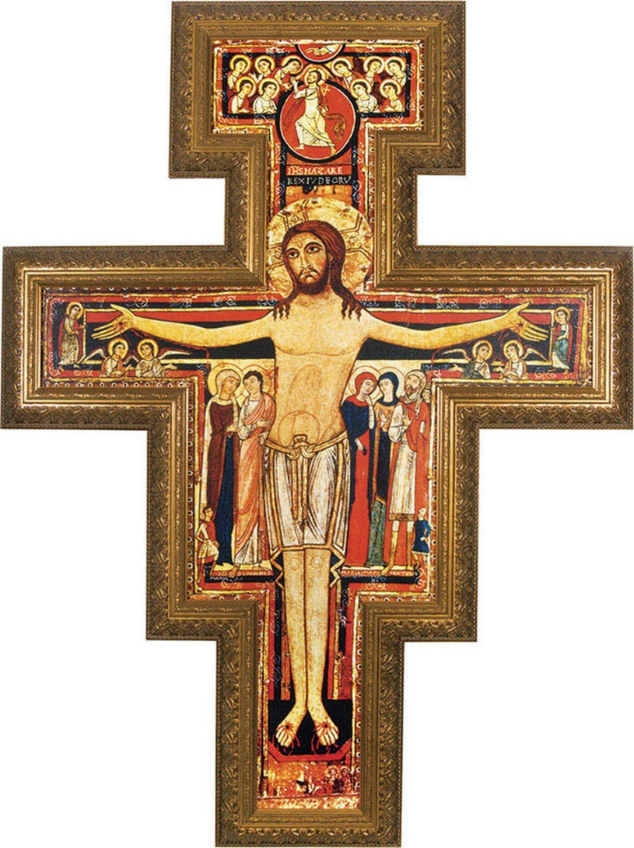

Bible Verse
Mark 15:20–32 CSB
After they had mocked him, they stripped him of the purple robe and put his clothes on him. They led him out to crucify him.
They forced a man coming in from the country, who was passing by, to carry Jesus’s Cross. He was Simon of Cyrene, the father of Alexander and Rufus.
They brought Jesus to the place called Golgotha (which means Place of the Skull).
They tried to give him wine mixed with myrrh, but he did not take it.
Then they crucified him and divided his clothes, casting lots for them to decide what each would get.
Now it was nine in the morning when they crucified him.
The inscription of the charge written against him was: The King of the Jews.
They crucified two criminals with him, one on his right and one on his left.
Those who passed by were yelling insults at him, shaking their heads, and saying, “Ha! The one who would destroy the temple and rebuild it in three days,
save yourself by coming down from the Cross!”
In the same way, the chief priests with the scribes were mocking him among themselves and saying, “He saved others, but he cannot save himself!
Let the Messiah, the King of Israel, come down now from the Cross, so that we may see and believe.” Even those who were crucified with him taunted him.
- The cross-bearer (15:21)

- The cup (15:22–23)

- The clothing (15:24–25)

- The citation (15:26)

- The criminals (15:27–28)

- The contempt (15:29–32)
Take Home Truth
- A cross-less king _________ _______ ______.

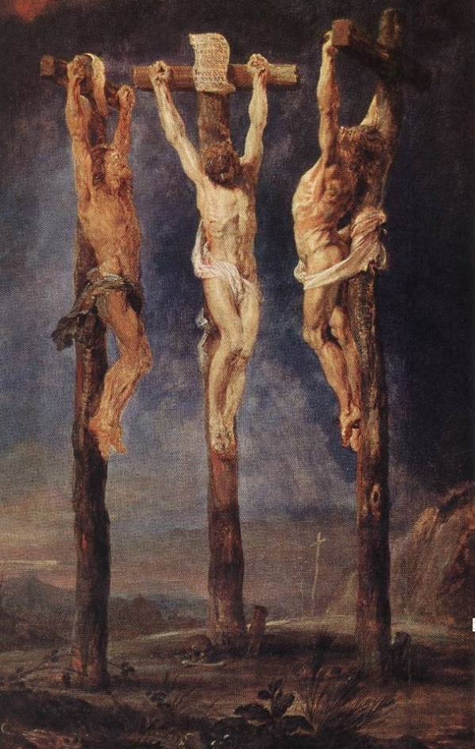

Luther: “And all the prophets saw this, that Christ was to become the greatest thief, murderer, adulterer, robber, desecrator, blasphemer, etc., there has ever been anywhere in the world.… In short, He has and bears all the sins of all men in His body—not in the sense that He has committed them but in the sense that He took these sins, committed by us, upon His own body, in order to make satisfaction for them with His own blood” (AE 26:277).

Pray
“Dear Jesus, I confess I am a sinner and deserve judgment and hell, but I believe You love, came to this earth for me, lived a sinless life, and died on the Cross for my sins. I believe God raised you from the dead to forgive me. Please forgive me, come into my life, and grant me eternal life in You name. Help me to glorify you in all I do. In Jesus’ name, Amen.”
• • •
Text BELIEVE to 706-525-5351.
• • •
www.mtcarmeldemorest.com/baptism
• • •
May the thought of the hard smiting of your head help me to bear my own bodily pain, of whatever kind it may be. May the thought of the scornful blindfolding of your eyes check the curiosity of mine. May the thought of the filthy spitting upon your beauteous countenance repress within me every fleshly lust, and may it teach me not to be dazzled by outward glitter, but to cultivate more earnestly than ever the inward graces of the soul. May the thought of the mocking which you had to bear make me shrink from all levity of behavior and from all foolish jesting; and may the thought of the utter setting at naught of your majesty quench in me all desire of being made much of, and lead me rather to seek a mean and lowly state. Amen.
THOMAS À KEMPIS

