# **Anxiety (Part 3): Causes, Curses, and Cures**

[Philippians 4:6](https://ref.ly/logosref/BibleCSB2.Php4.6)

# Instructions

• Will you take your Bibles and turn to [Philippians 4:6](https://ref.ly/logosref/BibleCSB2.Php4.6)? Please search the Scriptures with us. Don’t be afraid to use your index.

• If you don’t have a Bible but have a smartphone, you can download the Y-O-U Version Bible App. Once you download it, you can go to the “More” tab, tap “Events,” and find Mt. Carmel Baptist Church, and you can see the Scripture, notes, quotes, and references.

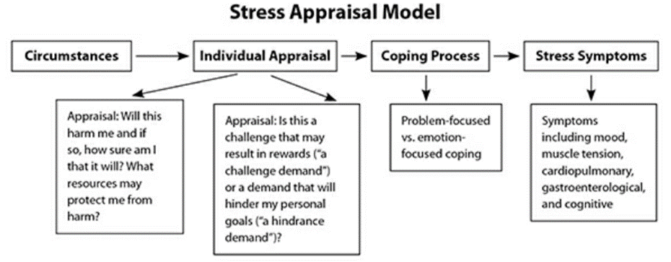

### 1. ___________ ___________

* Psalm 38:18 (CSB) So I confess my iniquity; I am anxious because of my sin.

* 1 Corinthians 7:32 CSB I want you to be without concerns. The unmarried man is concerned about the things of the Lord—how he may please the Lord.

Take-Home Truth

* **There is _______ to _______ from the _______ _______.**
* **Anxiety is relieved for the Christian, not so much by changing our** _________________ **as by changing our** ___________**.**
* [Philippians 2:19–24](https://ref.ly/logosref/BibleCSB2.Php2.19-24) (CSB) For I have no one else like-minded who will genuinely care about your interests; 21 all seek their own interests, not those of Jesus Christ.

### 2. ___________ Predisposition

* John 9:2 CSB His disciples asked him, “Rabbi, who sinned, this man or his parents, that he was born blind?”
* Exodus 4:11 CSB The LORD said to him, “Who placed a mouth on humans? Who makes a person mute or deaf, seeing or blind? Is it not I, the LORD?
* John 9:3 (CSB) “Neither this man nor his parents sinned,” Jesus answered. “This came about so that God’s works might be displayed in him.

### 3. ___________

* **James 1:8 (CSB)** being double-minded and unstable in all his ways.
* Yet, **1 Peter 3:15**, tells us to be ready to explain why we believe.

### 4. ___________

### 5. ___________

* Proverbs 14:10 (CSB) The heart knows its own bitterness, and no outsider shares in its joy.
* Acts 8:23 (CSB) For I see you are poisoned by bitterness and bound by wickedness.”
* Hebrews 12:15 (CSB) Make sure that no one falls short of the grace of God and that no root of bitterness springs up, causing trouble and defiling many.

### 6. ___________

Galatians 4:13–14 (CSB) you know that previously I preached the gospel to you because of a weakness of the flesh. You did not despise or reject me though my physical condition was a trial for you. On the contrary, you received me as an angel of God, as Christ Jesus himself.

# Repent and be baptized.

Text BELIEVE to 706-525-5351.

www.mtcarmeldemorest.com/baptism

• • •

# Pray

*Listen to my prayer, O God*,

*do not ignore my plea;*

*hear me and answer me*.

*My thoughts trouble me and I am distraught*

*at the voice of the enemy*,

*at the stares of the wicked;*

*for they bring down suffering upon me*

*and revile me in their anger*.

*My heart is in anguish within me;*

*the terrors of death assail me*.

*Fear and trembling have beset me;*

*horror has overwhelmed me*.

*I said, ‘Oh, that I had the wings of a dove!*

*I would fly away and be at rest—*

*I would flee far away*

*and stay in the desert; Selah*

*I would hurry to my place of shelter*,

*far from the tempest and storm’ …*

*… But I call to God*,

*and the Lord saves me*.

*Evening, morning and noon*

*I cry out in distress*,

*and he hears my voice …*

*Cast your cares on the Lord*

*and he will sustain you;*

*he will never let the righteous fall*.

*But you, O God, will bring down the wicked*

*into the pit of corruption;*

*bloodthirsty and deceitful men*

*will not live out half their days*.

*But as for me, I trust in you. (Psalm 55:1–8, 16–17, 22–23)*